Section 1: Case Summary

Scenario Title: | Airway obstruction
Keywords: | FB airway, respiratory arrest
Brief Description of Case: | This case involves a 60-year-old male patient who arrives VSA in PEA after collapsing while eating dinner with family. The collateral history included that he was suspected to be intoxicated. The patient arrives in PEA but is difficult to bag with EMS. The learner will have to work through the can’t ventilate/can’t oxygenate scenario once they identify that BVM is ineffective.

Goals and Objectives
Educational Goal: | Management of respiratory arrest secondary to a food bolus.
Objectives:  (Medical and CRM) | - Recognize the need to place an advanced airway when BVM is not effective in cardiac arrest  - Develop an approach to FB airway obstruction as a “can’t intubate, can’t ventilate” situation  - Demonstrate situational awareness by delegating tasks, establishing leadership, and making use of a shared mental model

Learners, Setting and Personnel
Target Learners: | ☐ Junior Learners |  | ☐ Senior Learners |  |  | ☒ Staff
 | ☒ Physicians | ☒ Nurses |  | ☒ RTs | ☐ Inter-professional
 | ☐ Other Learners:
Location: | ☐ Sim Lab |  | ☒ In Situ |  |  | ☐ Other:
Recommended Number of Facilitators: | Instructors: 1
 | Confederates: 1
 | Sim Techs: 1

Scenario Development
Date of Development: | Jan 2021
Scenario Developer(s): | Rosamaria North, CCFP-EM and George McKay, CCFP-EM
Affiliations/Institutions(s): | Northern Ontario School of Medicine, Thunder Bay Regional Health Sciences Centre
Contact E-mail: | rbava@nosm.ca
Last Revision Date:
Revised By:
Version Number: | 1

Section 2A: Initial Patient Information

- Patient Chart
Patient Name: Jeffery Smith |  |  |  | Age: 60 | Gender: M | Weight: 80 kg
Presenting complaint: VSA in PEA arrest
Temp: 36.2 | HR: 80 | BP: -- |  | RR: -- | O₂Sat: 60% | FiO₂: 100 %
Cap glucose: -- |  |  |  | GCS: 3 (E1 V1 M1)
EMS handover (advanced care crew): The patient was apparently eating dinner with family. They witnessed the patient collapse and started CPR. The initial rhythm was PEA and the patient has remained in PEA. We’ve inserted an IV and given 3 doses of epinephrine. There is an OP airway in place but the patient is difficult to bag.

Allergies: unknown
Past Medical History:  unknown |  |  | Current Medications:  unknown

Section 2B: Extra Patient Information

A. Further History
This patient was eating dinner and had been intoxicated according to the family members. He was talking, then appeared to collapse according to witnesses. Family started CPR immediately.
B. Physical Exam
Cardio: No pulses | Neuro: GCS 3
Resp: Bagging with BVM and OP in place, there is poor chest rise | Head & Neck: Pupils 3 mm, non-reactive
Abdo: Distended | MSK/skin: Cool and dry
Other: PoCUS demonstrates some cardiac contractility, no palpable pulse but there is a PoCUS pulse. No lung sliding bilaterally. No pericardial effusion. No AAA. FAST neg.

Section 3: Technical Requirements/Room Vision

A. Patient
☒ Mannequin (specify type and whether infant/child/adult)
☐ Standardized Patient
☐ Task Trainer
☐ Hybrid
B. Special Equipment Required
Airway equipment: ET tube, suction, bougie, syringe, laryngoscope, video laryngoscope, stylet
Magill forceps
Soft FB to insert into the airway
Cricothyrotomy kit

C. Required Medications
Epinephrine, calcium, bicarb, dextrose
Heliox (optional)

D. Moulage
Soft FB in the airway just beyond the cords (we used a piece of foam tied to a string so that it can be extracted from the mannequin)
Blood/secretions in the airway

E. Monitors at Case Onset
☐ Patient on monitor with vitals displayed
☒ Patient not yet on monitor
F. Patient Reactions and Exam
Difficult to bag with OP and BVM
On attempt at intubation a FB (food bolus) is identified sitting partially in the vocal cords
Attempt to remove the FB causes it to slip through the cords

Section 4: Confederates and Standardized Patients

Confederate and Standardized Patient Roles and Scripts
EMS | Deliver the patient with CPR in progress and provide collateral information
Bedside RN | Assist with starting IV, drawing labs and giving medications and updating with changes in vitals and preventing patient harm. Helpful and skilled.
RT | Assist with airway troubleshooting. Helpful and skilled.

Section 5: Scenario Progression

Scenario States, Modifiers and Triggers
Patient State/Vitals | Patient Status | Learner Actions, Modifiers & Triggers to Move to Next State |  | Facilitator Notes
1. Baseline State  Rhythm: PEA  HR: 80  BP: --  RR: --  O₂SAT: 60 %  T: 36. 2ºC  GCS: 3 | Patient unconscious | Expected Learner Actions  Continue CPR and BVM  Monitors, IV, limited vitals, cap BG  Identify initial rhythm  Verbalize potential Hs and Ts  Labs, PoCUS  Measure ET CO2 (25mmHg) | Modifiers  Attempt to continue BVMHR begins to fall into 40s and O2 sats do not improve  Can consider other medications based on Hs and Ts (epi, naloxone, bicarb, calcium, thrombolysis) but none are effective at achieving ROSC  Triggers  All other actions move to stage 2
2. Identify and treat hypoxia  Same as state 1 | Patient unconscious  Airway is full of secretions and some blood | Expected Learner Actions  Attempt to improve O2 sats with 2 handed BVM, flush FiO2, repositioning, and a NPA in addition to OPA  Can attempt an LMA  Move to intubation during which you will identify the FB with laryngoscopy  Manipulation of the FB with suction, Magills  Can try to “apple-core” the FB with ET tube  Force the FB into the right mainstem if other methods ineffective at retrieving the FB | Modifiers  If no attempt to improve hypoxia, patient deteriorates into asystole  LMA is still ineffective  If cricothyrotomy attemptef - ineffective (FB is below the level of the cricothyroid membrane)  Triggers  All actions complete move to stage 3
3. Airway secured  Rhythm: sinus tach  HR: 120s  BP: 60/40  RR: --  O2 sat: improves to 75%  T: 36.2  GCS: 3 | Patient unconscious and now easy to bag  Pulse palpable | Expected Learner Actions  Start vasopressors/inoptropes  Consider post intubation sedation and analgesia  Consult ENT, respirology, or thoracic surgery for bronchoscopy | Modifiers  Trigger  All actions complete move to stage 4
4. Stabilization  Rhythm: sinus tach  HR: 120s  BP: 100/60  RR: --  O2 sats: 100%  T36.2  GCS: 3 | Patient remains unconscious | Expected Learner Actions  Consult ICU  Post-ROSC care (ECG, labs, x-ray)  Consider cooling as still neurologically unresponsive post cardiac arrest | End of case

Appendix A: Laboratory Results

Obtained POST ARREST if ROSC:  CBC  WBC 20  Hgb 130  Plt 200  Lytes  Na 149  K 6  Cl 110  HCO3 14  AG 24  Urea 8  Cr 150  Glucose 7  VBG  pH 6.9  pCO2 60  pO2 60  HCO3 14  Lactate 9 | Cardiac/Coags  Trop 0.071  INR 1.1  Biliary  AST 150  ALT 160  ALP 170  Bili 30  Lipase 200  Tox  EtOH 80  ASA neg  Tylenol neg  Dig level neg  Osmols 303

Appendix B: ECGs, X-rays, Ultrasounds and Pictures

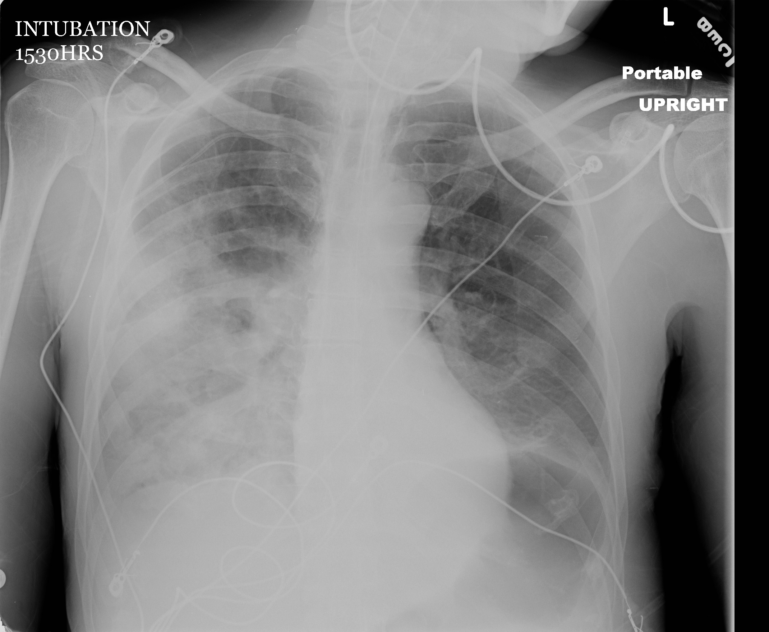

From: http://maryland.ccproject.com/wp-content/uploads/sites/3/2013/09/Necrotizing-Pneumonia.jpg

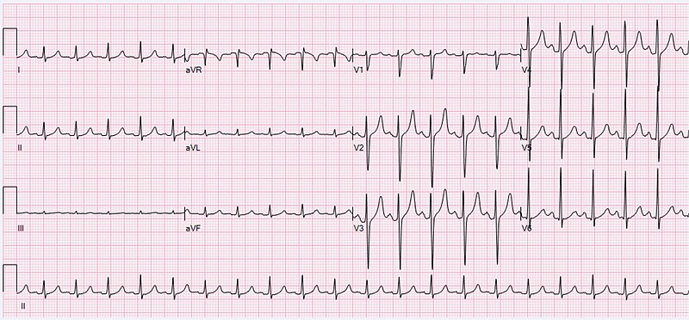
From Wikipedia (https://commons.wikimedia.org/wiki/File:ECG_Sinus_Tachycardia_125_bpm.jpg)

Appendix C: Facilitator Cheat Sheet & Debriefing Tips

Key decision making points in the case:
- Identify airway obstruction as the cause of cardiac arrest
- Stepwise approach to securing the airway with a FB present
- Utility of a cricothyrotomy with a FB present

Debriefing Topics:
- Varying clinical presentation of airway obstruction from FB
- Management of a partial vs. complete airway FB in an awake patient
- Management of a partial vs. complete airway FB in an unconscious patient
- Disposition of awake patients with a resolved FB
- Consideration of antibiotics in aspiration pneumonia
- Pediatric considerations

References

1. Rosen's Emergency Medicine (9th Edition). Chapter 60: Foreign Bodies.
2. Cardiac Arrest Following Foreign-Body Aspiration. 2011. Respiratory Care. http://rc.rcjournal.com/content/56/4/527.short
3. Pediatric Medical Resuscitation—The Airway. 2015. EMDOCS.net. http://www.emdocs.net/pediatric-medical-resuscitation-the-airway/
4. http://maryland.ccproject.com/wp-content/uploads/sites/3/2013/09/Necrotizing-Pneumonia.jpg
5. Hewlett, Justin C, Rickman, Otis B, Lentz, Robert J, Prakash, Udaya B, and Maldonado, Fabien. "Foreign Body Aspiration in Adult Airways: Therapeutic Approach." Journal of Thoracic Disease 9.9 (2017): 3398-409. Web.
6. Clinical presentation, diagnostic evaluation, and management of central airway obstruction in adults. (2020). UpToDate. https://www.uptodate.com/contents/clinical-presentation-diagnostic-evaluation-and-management-of-central-airway-obstruction-in-adults?topicRef=4387&source=see_link#H1

